**1.Create a directory ’project_dir ’ & cd to ‘ project_dir ‘.**

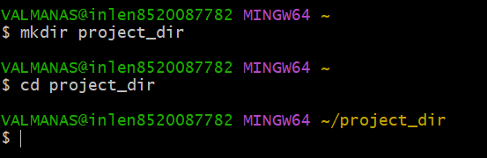

**2.Initialize git version database.**



**3.Create a new file index.html.**



**4.Check the git status. You should find index.html as untracked file.**

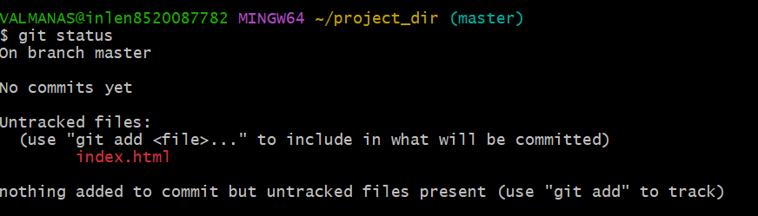

5.**Stage the index.html file.** 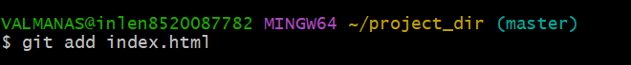

6.**Commit index.html.**

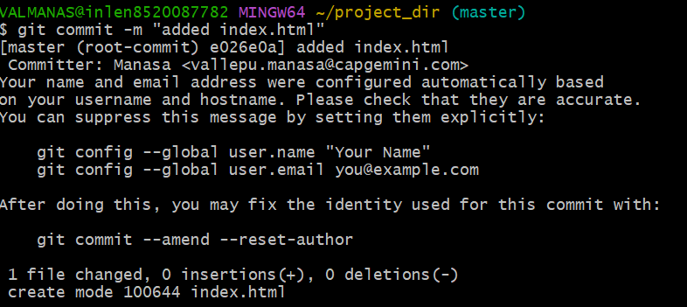

7.**Make few changes in index.html &create a new file info.txt file.**



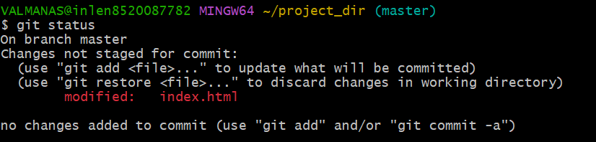



8.**Check git status. You should find index.html & info.txt as untracked files.**

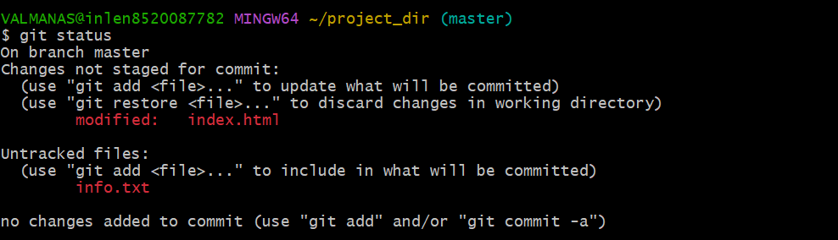

9.**Configure GIT to ignore all txt files.**



10. **Again check the git status. You should find only index.html as untracked file.**

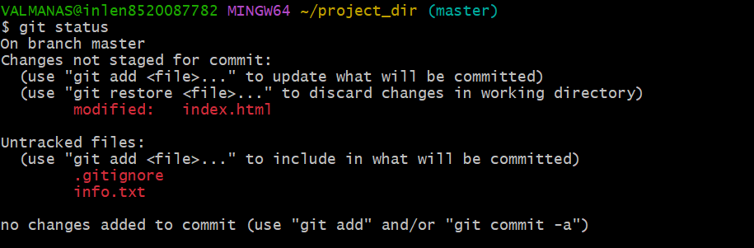11**. State & commit index.html.**

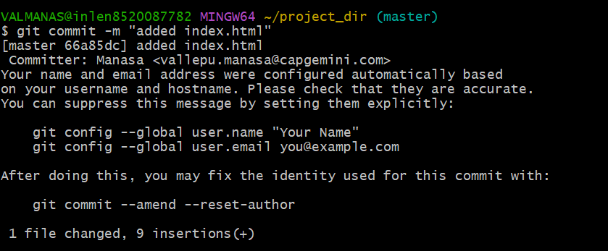

12. **Log all your comments so far.**

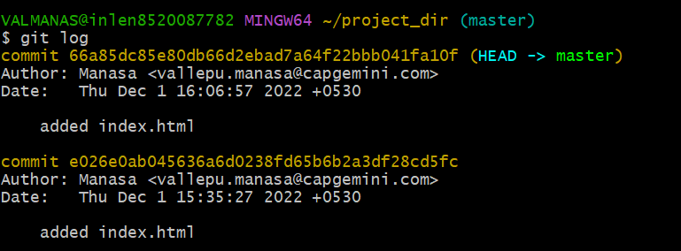

13. **Make some changes in index.html.**

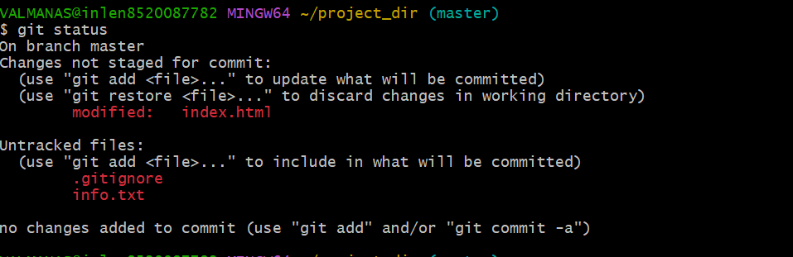

14. **Revert the change made in the previous step using git command.**

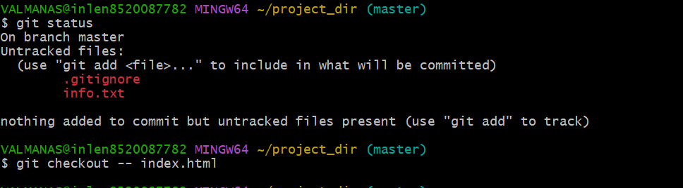

**15**. **Again change index.html.**

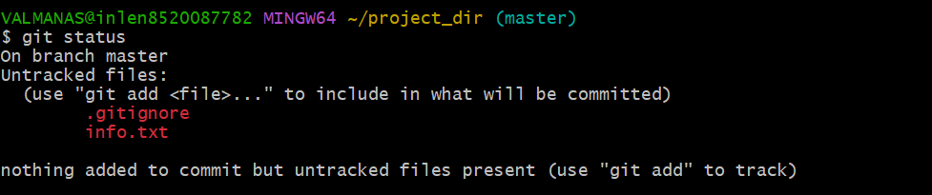

**16. Stage index.html.**



**17. Revert back the last stage.**



**18. Rename ‘add’ command to ‘my-add’.**

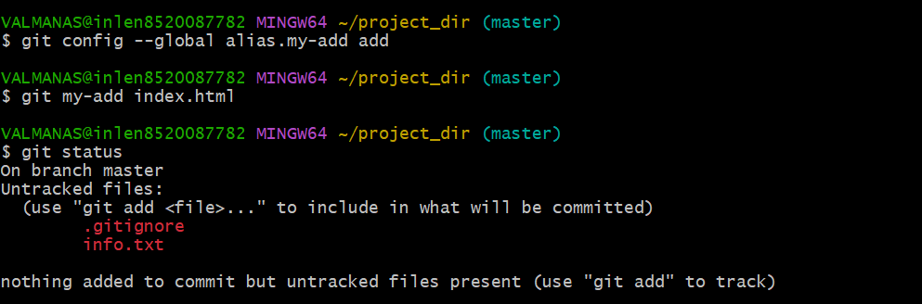

**19. Using my_add command Stage index.html again & commit the changes.**

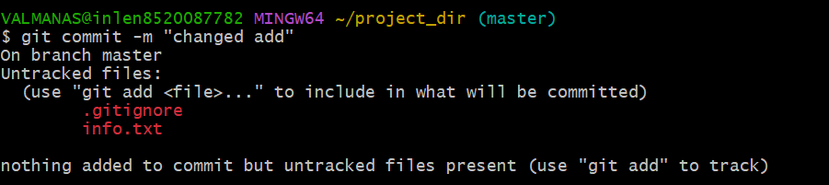

**20. Revert the last commit.**

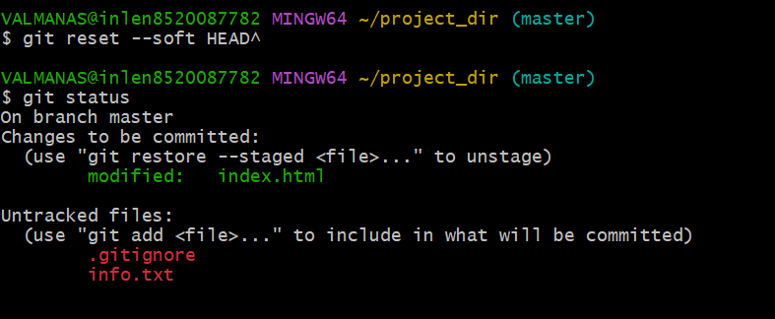

**22. Create an empty directory ‘Assignments’ & cd to ‘Assignments’.**

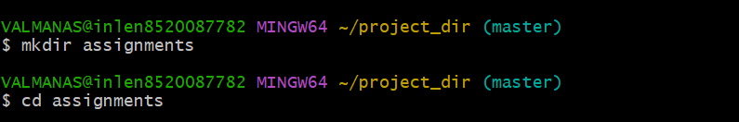

**23. Create a file README.txt inside ‘Assignments’ & write few lines about the contents of ‘Assignments’ folder.**

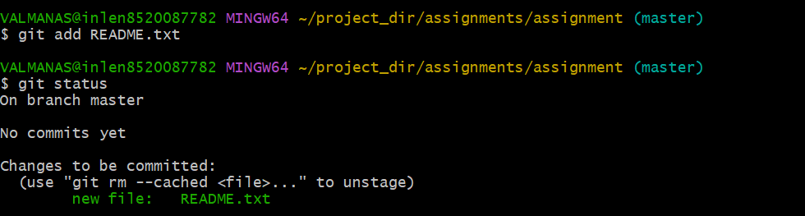

24. **Commit README.txt file.**

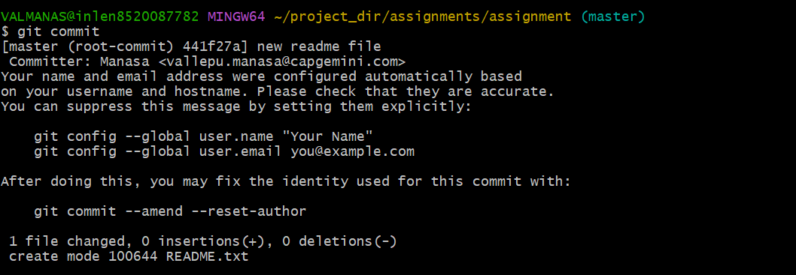

25. Now create a new branch ‘html-assignments’



26.Switch to ‘html-assignments’ branch.



27. Copy all HTML assignments inside ‘Assignments’ folder.



28. Commit HTML assignments into ‘html-assignments’ branch.



29. Make minor changes into few files belonging to ‘html-assignments’ branch



30. Commit those changed files

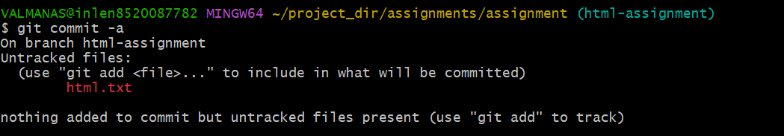

31. Switch to master branch



32. Make minor changes into README.txt file & commit those changes into master

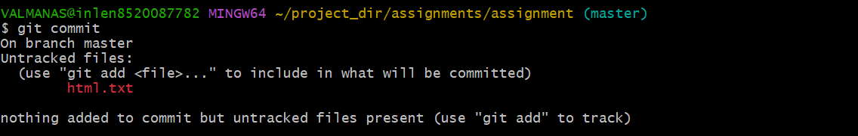

33. Again switch to ‘html-assignments’ branch



34. Make minor changes into few files belonging to ‘html-assignments’ branch

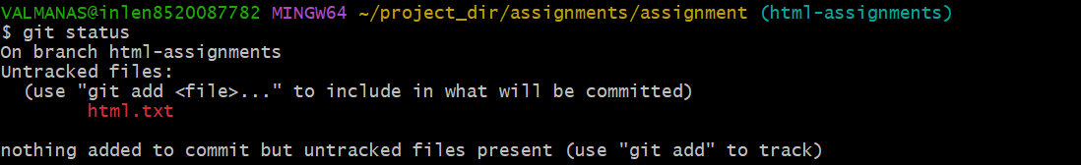

35. Commit those changes

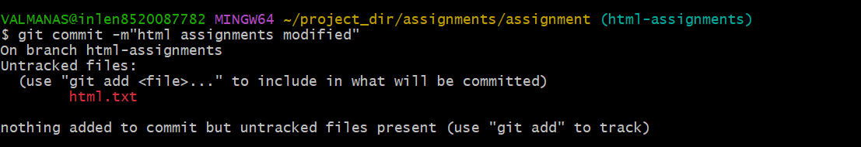

36. Switch to master



37. Merge ‘html-assignments’ branch into master. Confirm all html assignments are shown in master.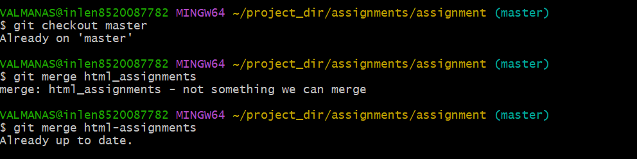

38. Finally delete the ‘html-assignments’ branch

